Czech cuisine
What makes Czech cuisine worldwide famous is a beer. It’s so famous, that the rest of the cuisine is a mystery in its shadow. So, I have to start the introduction with beer…

Beer
Yes, Czech beer is really good and is considered one of the best in the world. To be precise, in this case we’re talking mainly about Pilsner type lagers and these can be light, semi-dark or dark.
It has to be mentioned, that not all Czech beers are good (even though it may be still considered above worldwide average). Reliable guide to the quality is the price in grocery store – restaurants charge how much they dare, especially in tourist areas.
You had probably tasted world known labels as Pilsner Urquell or Budweiser Budvar. Even though they are good and set the style, much more variety is provided by local or craft breweries. What you can most frequently find on tap in Prague follows (with my personal judgment):
Major breweries and their brands
Plzeň (Pilsen) - Pilsner Urquell (premium), Gambrinus (bland), Kozel (acceptable)
Staropramen - all labels bland to acceptable except Braník (poor)
Krušovice – all labels bland to acceptable
České Budějovice (German: Budweis) – Budvar (labels from premium to acceptable), Pardál (acceptable to poor)
Note: this is not a copy of US Budweiser, but the original (coming from the name of the city where it’s brewed)
Middle size breweries
Svijany – Svijany (all labels good; beer with low level of bitterness)
Lobkowicz – Lobkowicz, Černá Hora, Primátor, Platan, Ježek and other brands (all labels good to acceptable; consorcium of small breweries)
Bernard - difficult brand trying to discover new tastes, but it’s mostly good
Local or craft breweries are so numerous and specific, that it has to be tasted, not described… 😊 Most breweries try to produce various specials – the smaller brewery, the more specials. And most of them are GOOD. I personally prefer tasting local beers, there’s always something new…

Other local drinks

Kofola
Kofola is Cola-like soda which was invented in 1960’s as a local answer to Coca Cola. It gained a massive popularity throughout the years. It has specific taste and is not so sweet as Classic Coke or Pepsi. They usually provide some small funny gifts during the summer if you order two or more big glasses.

Wine
In southeastern part of Czech Republic is grown very good white wine, esp. varieties Rulandské (Pinot), Ryzlink (Riesling) or you can try local vintage Muškát moravský. Red wines are rather light because there’s not enough sunshine but are worth a try too, typical are Svatovavřinecké (St.Laurent), Frankovka (Blaufränkisch) and their crossbreed Zweigeltrebe. Good wine cellar is Blatnička (http://www.restaurace-blatnicka.cz/kontakt.html ) in historical center.

Beer snacks
Somewhere the meeting place for people is a tea room, somewhere open cafés, in another places it’s bars, or just sidewalk. The meeting place for Czechs is a pub. When you spend your time at the table discussing the world problems with mug in your hand, some snacks come handy. Here are the typical:

Utopenec (pickled sausage)
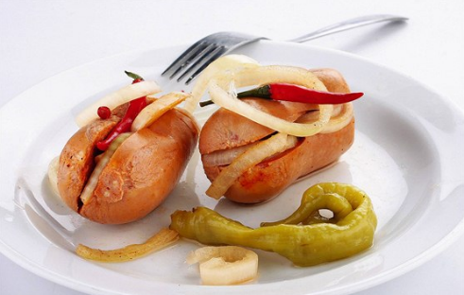
The literal translation of this meal is “drowned man” and is derived from its preparation. Pork sausage together with onions, chili peppers or other vegetables is macerated in vinegar and spices. It is served cold with bread.
Well done utopenec is delicious with beer, but some pubs serve it too sour.

Tlačenka
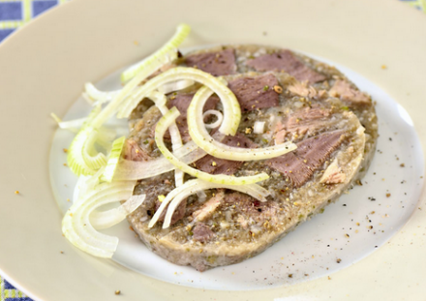
Small pieces of pork compressed together and keeping shape by broth jelly. It’s served cold with raw onion and/or pickles and vinegar, together with bread. It’s better to have the vinegar apart, otherwise somewhere you get it too sour.

Zavináči (pickled herrings)
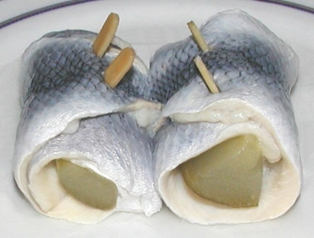
Herrings staffed with carrots, parsley, onions and pickled in sour solution. It’s popular also in Scandinavia.

Matjesy (macerated herrings)
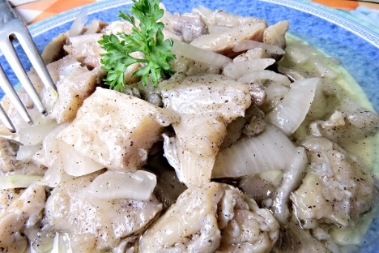
Matjesy are herrings macerated in vegetable oil together with spices and onions. It’s salty so it makes you thirsty. The meal is served cold with bread.

Nakládaný hermelín (macerated cheese)
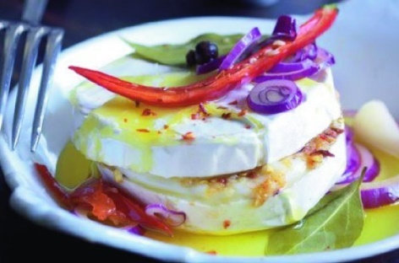
There’s a variety of pickled cheeses, but most popular and common is Hermelín, which is a local version of Camembert. You’d encounter it most likely staffed with garlic, onion, chilies, sometimes cranberries. It’s macerated in vegetable oil.
It shouldn’t be served directly from the fridge, but it’s served cold with bread.

Škvarky (graves)
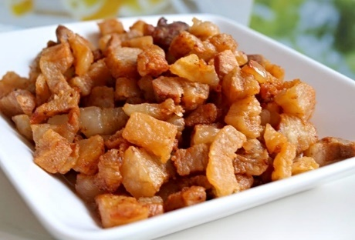
Graves are what is left in kettle after lard is produced. Therefore, it’s mainly pork fat, but crunchy roasted. It’s served as it is or mixed with lard (škvarková pomazánka). Onion, mustard and salt is usually added, served with bread.

Talián
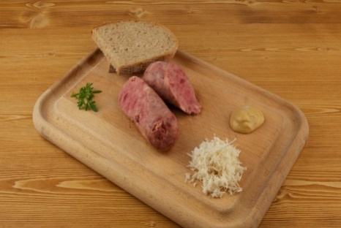
is soft pork and beef sausage which is boiled (not smoked or roasted). It’s soft with distinctive meat flavor.
Talián is served with mustard, horseradish and bread.

Grundle
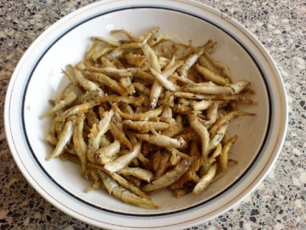
You perhaps wouldn’t encounter this meal very often, but it’s interesting, so I’ll describe it anyway. It’s small fish covered by flour and deep fried.
You eat it whole, slowly the same way as chips or pretzels…

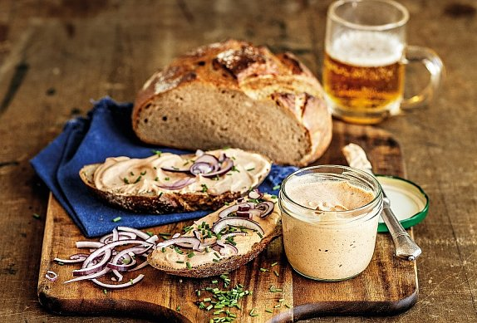
Pivní sýr

Literal translation is “beer cheese”. This meal is made from really ripe cheese, onions, mustard and beer. It is served in a bowl with a variety of spices and it is expected that you finish it according to your taste. Don’t be afraid to add more beer. The result should be in a form of aromatic smooth paste. But be warned – the smell is hell, the taste is (supposed to be) heaven.

Pečené koleno (roasted pork knee)
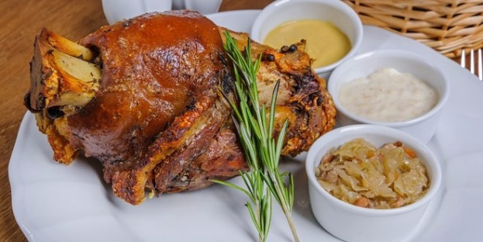
In several restaurants you can also find roasted pork knee, which is not exactly a snack, but is usually eaten while drinking beer.
It is served mostly as a whole, which means it looks huge, but there’s the bone, fat and skin. As a side is usually mustard and horseradish, it’s eaten with bread.

Soups
People living in contemporary Czech Republic were mostly hard-working individuals in agriculture or industry whole year around. Therefore, all meals were substantial.
Good example can be soups bramboračka (potato soup) or zelňačka (sauerkraut soup). There’s many local varieties of both of them. Bramboračka is best with wild mushrooms but there’s just small difference between local varieties. Zelňačka differs much more – western type is more sour, the easternmost variety (kyselica) is smooth and rich with cream.
Interesting soup is kyselo which originated in northern mountains (Krkonoše). It’s based on bread ferment, wild mushrooms and dill.

Main courses
Fifty years of planned economy and communism decimated except other things also culinary customs of local people. Thus variety of meals affordable in the beginning of 20th century vanished and only now are being discovered again. What would be described further are therefore only remnants which are tasty and in one example peculiar.
Contemporary so called “traditional” Czech meal is a slice of meat, sauce and dumplings as side dish. From this basic spring out most popular (common) meals, typical examples are below. Of course you can find places with more elaborate chef, but average state is described. If you order any kind of steak or other meal from the menu which doesn’t contain dumplings, be prepared to find a small pile of radish or blend of raw or pickled vegetables on the side of your plate which don’t necessarily suit to your meal...

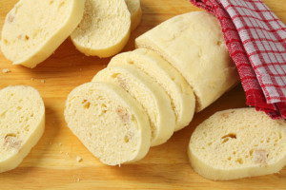
First let me explain dumpling (knedlík): there are two basic types – bread or potato. Both are made of wheat flour dough with yeast added and then boiled. The difference is what is added to the dough apart of the flour – potatoes or bread. Primary shape is loaf, which is then sliced in similar way as bread. Potato dumplings are close to very large gnocchi, bread dumplings are on the picture.
Interesting variety of dumplings are those filled with fruits (ovocné knedlíky). These are small balls most often filled with plums, strawberries or blueberries topped with sugar, cocoa and/or sour cream and cottage cheese. And they’re delicious, you should try them.

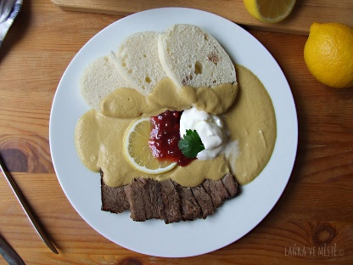
Svíčková – slowly roasted beef with vegetable cream sauce and bread dumplings. Topped with cream and cranberries. When the chef knows his job, it’s delicious.
Vepřo-knedlo-zelo – roasted pork with cooked sauerkraut and bread dumplings. Pork is sometimes substituted by roasted duck. Sauerkraut can be both - white or red and varies regionally.
Špenát – potato dumplings are mostly eaten with spinach and smoked pork
Smažený sýr – invented sometimes during shortage in stores during communist times but very popular since then. Slice of cheese is covered with eggs and bread crumbs (same way as wiener schnitzel) and fried. Served with potatoes or French fries and tartar sauce. Surprisingly it’s still the only vegetarian meal in some of the restaurants…

